1. Manual testing
2. *Every test in this document is written in the assumption that everything else in the application works as intended. The tests will refer to figures, these can be found last in this document.*

**ID:** 1

**Activity:** MenuScreen

**Function:** take_Pic_B

**Description:** Test the “Take Pic” button in MenuScreen and make sure that it does what it’s supposed to.

**Steps:   
*1.*** Start the application**.  
*2.*** You should now be looking at the MenuScreen that is activated at the execution of AsciiCam. (See figure 1).  
***3.*** Press the “Take Pic” button. This action should activate the CameraScreen activity, which is supposed to show the phones camera as background.

**Result:** CameraScreen activity is started and ready for use.

**ID:** 2

**Activity:** MenuScreen

**Function:** load_Pic_B

**Description:** Test the “Load Pic” button in MenuScreen and make sure that it does what it’s supposed to.

**Steps:   
*1.*** Start the application**.  
*2.*** You should now be looking at the MenuScreen that is activated at the execution of AsciiCam. (See figure 1).  
***3.*** Press the “Load Pic” button. This should open the phones gallery and let you browse the saved pictures on the phone.   
***4.*** Choose a picture to load and touch it. Now PreviewScreen should be activated, and the chosen picture should be loaded as background.

**Result:** PreviewScreen activity is started and got the chosen picture ready for use.

**ID**: 3

**Activity:** MenuScreen

**Function:** optionsB

**Description:** Test the “optionsB” button in MenuScreen and make sure that it does what it’s supposed to.

**Steps:   
*1.*** Start the application**.  
*2.*** You should now be looking at the MenuScreen that is activated at the execution of AsciiCam. (See figure 1).  
***3.*** Press the “Options” button. This should start the OptionScreen activity where you can change some settings within the application.

**Result:** OptionScreen activity is started and is ready for use. (See figure 5).

**ID:** 4

**Activity:** PreviewScreen

**Function:** loadFromCamera()

**Description:** Test the “loadFromCamera()” method in PreviewScreen and make sure that it loads the picture taken with the camera as background.

**Steps:   
*1.*** Start the application**.  
*2.*** You should now be looking at the MenuScreen that is activated at the execution of AsciiCam. (See figure 1).  
***3.*** Press the “Take pic” button. You should find yourself oriented to the CameraScreen activity (See figure 2) where you can take a nice picture with the button in the middle. If your testing device is a bit slow you might have to wait a couple of seconds for a result.

*Figure 1 - MenuScreen*

**Result:** PreviewScreen activity is started and got the taken picture loaded as background ready for use. (See figure 3).

**ID:** 5

**Activity:** PreviewScreen

**Function:** loadFromPhone()

**Description:** Test the “loadFromPhone()” method in PreviewScreen and make sure that it loads the picture that is chosen from the gallery and set it as background.

**Steps:   
*1.*** Start the application**.  
*2.*** You should now be looking at the MenuScreen that is activated at the execution of AsciiCam. (See figure 1).  
***3.*** Press the “Load Pic” button. You should now be browsing the phones gallery, choose a picture to load.

**Result:** PreviewScreen activity is started and got the chosen picture loaded as background ready for use. (See figure 3).

**ID:** 6

**Activity:** PreviewScreen

**Function:** convert_btn

**Description:** Test the “convert_btn” button in PreviewScreen and make sure that it convert the picture as supposed to.

**Steps:   
*1.*** Orient yourself to PreviewScreen, either by taking a picture with the camera or by loading a picture from the phone.  
***3.*** Press the “Convert” button and wait for a few seconds, depending on the current settings and the hardware in the testing device this might take some time. (See figure 3).

**Result:** ConvertedPicScreen should now be started and the background should be set to the background from PreviewScreen converted to ascii art. (See figure 4.)

**ID:** 7

**Activity:** PreviewScreen

**Function:** save_pic_btn

**Description:** Test the “save_pic_btn” button in PreviewScreen and make sure that it saves the picture when supposed to and that it doesn’t when it’s not supposed to.

**Steps:   
*1.*** Orient yourself to PreviewScreen, either by taking a picture with the camera or by loading a picture from the phone. ***2.*** Press the “Save” button. (See figure 3). If the picture is loaded from the gallery a dialog should pop up with the message “The picture is already saved”. If the picture is taken with the phone, press the button again. This should cause the same dialog to pop up. Go check for the picture in the gallery.

**Result:** You will find the picture you saved in the phones gallery, but it should only appear once.



**ID:** 8

**Activity:** ConvertedPicScreen

**Function:** options_btn

**Description:** Test the “options_btn” button in ConvertedPicScreen and make sure it orients to the OptionScreen with the right options.

**Steps:   
*1.*** Orient yourself to ConvertedPicScreen either by taking a picture with the camera or by loading a picture from the phone and converting it to ascii art. ***2.*** Press the “Options” button. (See figure 4).

**Result:** The OptionScreen activity should be activated with the settings that should be available after the conversion is done. (See figure 5).



**ID:** 9

**Activity:** ConvertedPicScreen

**Function:** save_btn

**Description:** Test the “save_btn” button in ConvertedPicScreen and make sure that it saves the converted picture on the phones memory.

**Steps:   
*1.*** Orient yourself to ConvertedPicScreen either by taking a picture with the camera or by loading a picture from the phone and converting it to ascii art.  ***2.*** Press the “Save” button. (See figure 4). Press the button again, this should cause a dialog to show up with the message “The picture is already saved”.   
***3.*** Open the phones gallery and look for the converted picture.

**Result:** You will find the converted picture saved and visible in the gallery.



**ID:** 10

**Activity:** OptionScreen

**Function:** Grayscale filter

**Description:** Test the “Grayscale filter” with the filterSpinner in OptionScreen and make sure that it converts the picture to grayscale.

**Steps:   
*1.*** Orient yourself to ConvertedPicScreen either by taking a picture with the camera or by loading a picture from the phone and converting it to ascii art.  ***2.*** Press the “Options” button. (See figure 5).  
***3.*** Now the activity OptionScreen should be activated. (See figure). Press the filter spinner.  
***4.*** A pop up will show up with 3 alternatives. Change to “Grayscale” and press “back”.

**Result:** The background in ConvertedPicScreen should be converted in grayscale instead of asciiart.



**ID:** 11

**Activity:** OptionScreen

**Function:** bgSpinner

**Description:** Test the “bgSpinner” spinner in OptionScreen and make sure that it change the color of the background when converting with asciifilter.

**Steps:   
*1.*** Orient yourself to ConvertedPicScreen either by taking a picture with the camera or by loading a picture from the phone and converting it to ascii art.  ***2.*** Press the “Options” button. (See figure 5).  
***3.*** Now the activity OptionScreen should be activated. (See figure). Press the background spinner.  
***4.*** A pop up will show up with 7 color alternatives. Pick one of the colors and press” back”.

**Result:** The background in ConvertedPicScreen should be a converted ascii art picture with the backgroundcolor you picked.



**ID:** 12

**Activity:** OptionScreen

**Function:** charSpinner

**Description:** Test the “charSpinner” spinner in OptionScreen and make sure that it change the color of the characters when converting with asciifilter.

**Steps:   
*1.*** Orient yourself to ConvertedPicScreen either by taking a picture with the camera or by loading a picture from the phone and converting it to ascii art.  ***2.*** Press the “Options” button. (See figure 5).  
***3.*** Now the activity OptionScreen should be activated. (See figure). Press the character spinner.  
***4.*** A pop up will show up with 7 color alternatives. Pick one of the colors and press” back”.

**Result:** The background in ConvertedPicScreen should be a converted ascii art picture with the characters in the color that you picked.



**ID:** 13

**Activity:** OptionScreen

**Function:** BrightnessFilter

**Description:** Test the “BrightnessFilter” with the filterSpinner in OptionScreen and make sure that it change the brightness of the picture.

**Steps:   
*1.*** Orient yourself to ConvertedPicScreen either by taking a picture with the camera or by loading a picture from the phone and converting it to ascii art.  ***2.*** Press the “Options” button. (See figure 5).  
***3.*** Now the activity OptionScreen should be activated. (See figure). Use the brightnessbar above the filterspinner. ull the bar to the right for a brighter picture and to the left for a darker picture.

**Result:** The background in ConvertedPicScreen should be changed to either darker or brighter depending on how you used the bar.

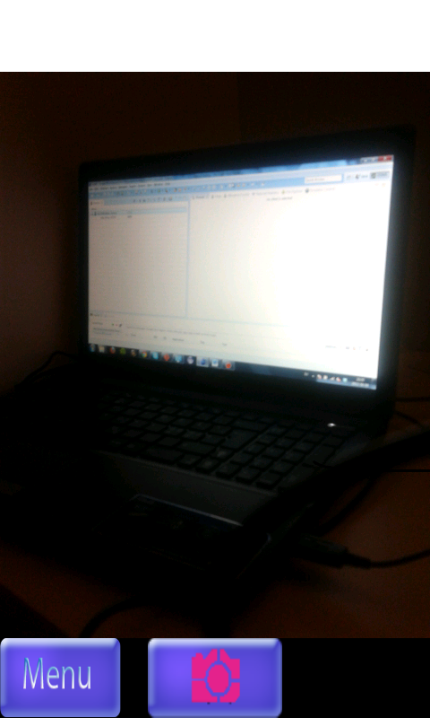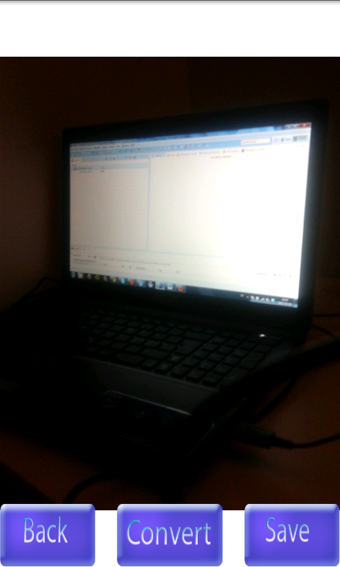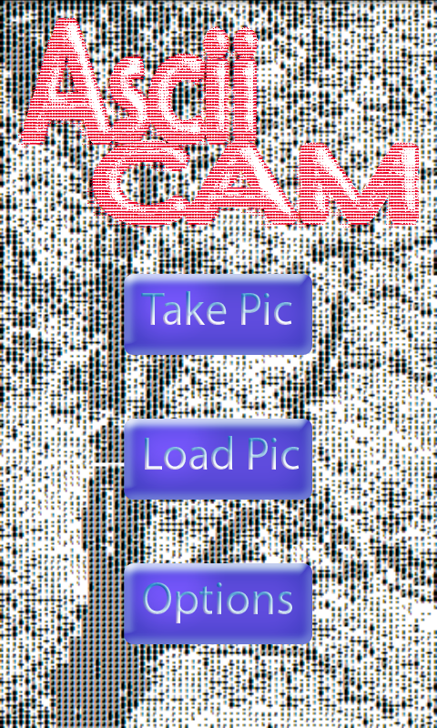

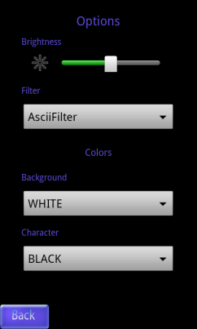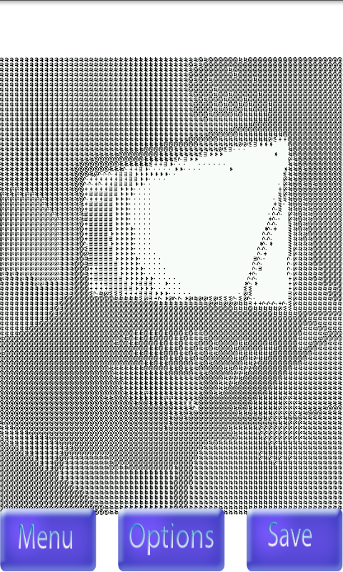

*Figure 5 - OptionScreen*

*Figure 4 - ConvertedPicScreen*

*Figure 3 - PreviewScreen*

*Figure 1 - MenuScreen*

*Figure 2 - CameraScreen*